# Activity 2_ Rental Car City ERD Instructions

Directions: Using the Excel spreadsheet, Rental Car City, create an ERD.

You may use the software of your choice, but Lucidchart is very user friendly. Below are detailed instructions using Lucidchart.

Go to **lucidchart.com**

Click **Sign up free**

Click **Continue with Free**

I signed up with **Google**

When the program opens, click on **+New**

Click **Lucidchart** > **Blank Document**

You are ready to click an **Entity Relationship template** and drag it onto the canvas.

You are now on your way to creating your first entity for your ERD.

Continue working through the data in the Rental Car City spreadsheet until you have developed an ERD that can hold all entities and attributes in the data set.

Don’t forget to use lines to demonstrate the relationships between the entities.

**Sample ERD**

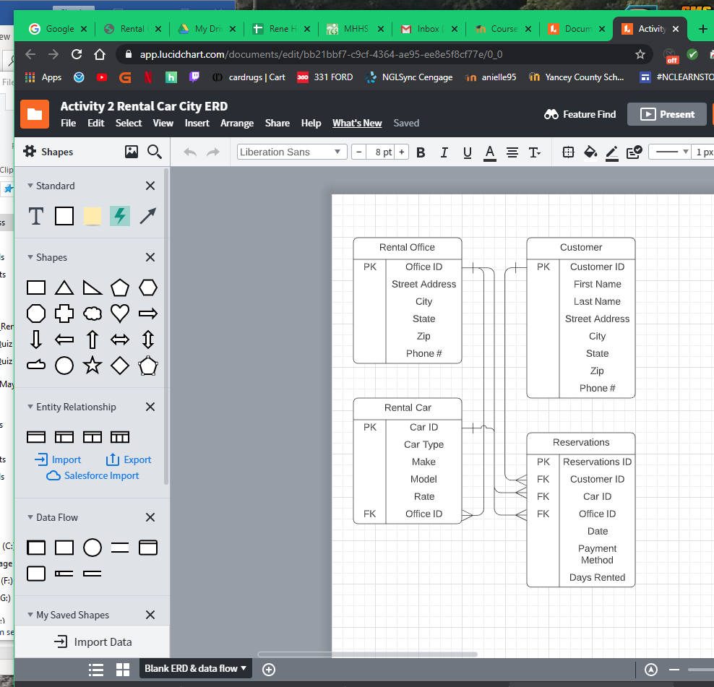

**This is the ERD I completed for the video. You may refer to it, as this is a guided practice activity.**

When you have completed your ERD, **rename** to **Fname_Lname_Activity_2_ERD.** (click **File** to **Rename**)

Click **File**

Click **Share Document**

**Enter** my email address: **karenrhughes@abtech.edu**